A-I Controlled Player for Shapez

*Fish Obsessed*

Table of Contents

Introduction...............................................................................

Justification...............................................................................

Rationale Behind the Prototype design.............................

Implementation Choices...................................................

Decision-Making Process.................................................

Tools and Technologies............................................................

Tools used.........................................................................

Technologies Integrated....................................................

Justification.......................................................................

Competitive Analysis................................................................

Positioning in the Market..................................................

Competitive Advantage.....................................................

Project Management and Collaboration....................................

Team Organisation............................................................

Ethics, Security and Data Privacy.............................................

Risk Matrix.......................................................................

Future Risk Mitigation......................................................

Evaluation.................................................................................

Conclusion................................................................................

Bibliography..............................................................................

Task Description and Rubric

Your team documentation should include

1. An introduction that explains what your product prototype is, why the product is important and innovative and what problem it solves.
2. Justification for your prototype implementation choices, what you chose to implement, what you mocked up to illustrate functionality. Why you made the decisions you made.
3. A justified explanation of the tools and technologies you used and why these were the right ones to use.
4. Position your prototype within the competitive landscape and justify your choices based in sound research.
5. Detail the team project management and collaboration processes you used and how you structured your work to achieve project goals.
6. Detail the ethics, security and data privacy considerations relevant to your team project including a matrix of your identified risks, impacts and mitigations what eventuated and a reflection on what you would do in the future to limit these risks.
7. Detail your evaluation approach and reflect on what you learned from stakeholders.
8. A conclusion that summarises the main points from the technical report with recommendations for future development of your prototype.
9. A consistently formatted bibliography of relevant reference material and attribution of all external sources used.

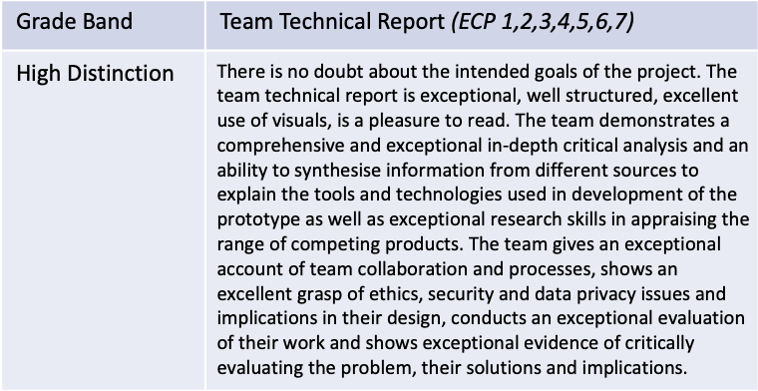

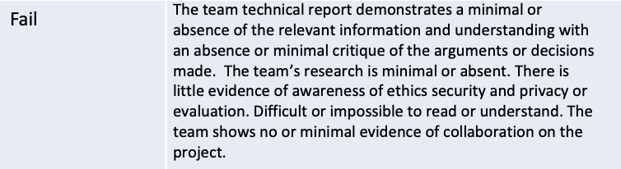

Introduction

. An introduction that explains what your product prototype is, why the product is important and innovative and what problem it solves

Our project centres around the creation of an autonomous AI game player designed for Shapez. Our AI Model handles resource gathering, production planning, and factory expansion, all while optimising key factors such as space, time, and resource efficiency. Additionally, the system should be able to understand and adjust to the changing environment within the game, adapting its strategies in real time as the game progresses and levels and shapes become increasingly complex.

We have chosen to develop a model that is unsupervised or semi-supervised. This means that we gave reduced the need for extensive labelled data, thus the AI can evolve alongside the game, learning from the game environment itself rather than relying solely on pre-fed information. This gives the AI a level of adaptability and flexibility, ensuring it can handle increasingly complex levels without manual reprogramming.

* We used Shapez open-source code from GitHub in JavaScript
* Our use of python libraries like TensorFlow,
* Used a rest API to communicate between python and JavaScript

The signficance of our project lies in its potential to solve a common challenge in real factories: optimising mechanics to reduce time spent on resource management and layout planning. ADD more

Justification

**Source Code and Mods:**

The base of our model is constructed from the source code of Shapez available on git [1]. We have utilized this code base and implemented our model through class overrides and the inbuilt modding API. We did this because by working from the game state, we can avoid implementing an advanced model that would need to analyse and learn the game state through pixels on a screen. We will use this API to send information and commands back and forth to our model which will be developed in Python. This allows access to existing Python libraries, such as TensorFlow and Py Torch, while retaining the game's inbuilt JavaScript core.

**Model:**

We have built a neural network that will be trained through deep reinforcement learning. Using neural networks for training an AI bot to optimize our Shapez.io environment has various advantages and drawbacks. One of the key benefits is its ability to handle complex, high-dimensional inputs. This is essential in this instance where our model will need to handle multiple factory variables, production rates, and resources. When combined with reinforcement learning methods, such as deep Q-learning, they can efficiently learn optimal strategies for optimisation. The downsides of this however is implementing a neural network will require a large amount of data and the training process and hyperparameter tuning can be time-consuming. The "black box" nature of neural networks also complicates things as it's not always clear why the AI is choosing certain options. For our algorithm, our initial thoughts led us to think an evolutionary algorithm may be preferable because of its capacity to learn unsupervised. Following additional research we decided to develop a Q-learning model. This is because this uses a reinforcement learning algorithm used to learn the optimal actions in each environment. We will need to create a well-defined reward and utility function for the agent taking actions in a current state which it will then attempt to optimise. Once the model is fully trained, the agent will then know the best action for each current state.

|  |  |  |
| --- | --- | --- |
| Model | Pros | Cons |
| Evolutionary algorithm | * Can be effective for complex tasks like our games where there are not clearly defined rewards for actions * Can handle **multi-objective optimization** (e.g., balancing resource consumption, production speed, and output quality) * Unsupervised * Good at exploring a large variety of possible solutions | * Will increase training time dramatically (likely time by num children) * Lots of hyperparameters (mutation rate, num children, plus all regular neural network ones) * High computational cost |
| Q-learning | * Quicker training time * Can learn optimal policies through interaction with the environment * Well-suited for incremental learning * Works well when paired with function approximators (e.g., neural networks) * Can handle **dynamic environments** where conditions (e.g., factory inputs or constraints) change over time | * Need a way of evaluating exact states * Requires reward shaping * Prioritises initial rewards over long term rewards * Requires large state-action table |

**Decision Making:**

For our model to work, it will need to have real-time decision capabilities. The way we are implementing this is by updating the model after every action or series of actions. For example, the process could go from model(state1) -> action, apply action to state1 to get state2, and model(state2) -> action and repeat. Relate this to visualisation tool

**Performance Metric and Visualisation:**

The performance metric will be based around the goal function will involve...

our initial ideas around visualisation included a loss or performance metric vs. epoch graph. This would be a useful tool while developing as well, as it would allow us to check the model's progress over time. We also thought it would be effective to create a video of the model playing the game at different times of training.

Additionally, trying to create some type of visualisation of "what the model is thinking" would be a good idea for presenting the results of the project to other people. This is a classic problem in machine learning as often these models are viewed as black boxes of sorts, and it is not known exactly what the model is doing.

What did we do? Visualisation of the model performance will include

**Shapezy:**

Our AI assistant Shapezy is a visualization tool for users. It will act as an autonomous AI assistant for intelligently managing factory production. Can interact partially or fully ...

Competitive Analysis

**Competitive Analysis: AI Assistants in Gameplay**

The market for AI assistants in gameplay has been growing rapidly with the rise of automation, machine learning, and increased focus on player experience. These AI assistants serve a wide range of functions, from helping players with complex in-game decisions, offering hints or guides and optimizing gameplay strategies.

**Existing Products:**

1. **Microsoft (Clippy-style AI):** While Clippy from Microsoft Office wasn’t for games, it pioneered the concept of AI-assisted user interaction, influencing the modern generation of in-game AI assistants.
2. **Discord’s Clyde Bot and AI integration:** Discord is a popular platform among gamers, and its bots are widely used to manage gaming communities. Its newer AI features, which could be expanded into gameplay assistants, offer smart suggestions and management of in-game events.
3. **Ubisoft’s Sam:** Sam is an in-game personal gaming assistant that provides insights, tips, and support to players. It helps players keep track of achievements and provides recommendations based on past behavior.

**Competitive Analysis: AI Factory Optimization**

The clear beneficiary for this project is those who enjoy factory and logistics games, and perhaps the wider genre community. The less obvious beneficiary is from the Research and Development on logistics and optimization, which is extremely beneficial for large industries and international transport networks. The integration of artificial intelligence and machine learning technologies in today's environment plays a pivotal role in the optimisation of supply chain, transportation and operation in any large-scale factory environment. The industry faces challenges in the ability to manage large inventories over numerous locations with constantly changing consumer demands and environments. These technologies “provide the ability to analyse vast amounts of data to predict demand, optimize routes, and manage inventory levels” [2]. In return, these models can provide invaluable analytics and insights which can allow companies to optimise decision making and address disruptions. Much like our implementation of Shapez clearly established goals are also crucial to efficiency.

**Existing Products:**

**Competitive Advantage:**

Expand

Project Management and Collaboration

* Team Organisation

Effective project management

Our meetings followed a consistent schedule. We would meet every Friday during the allocated time for about 2-4 hours and then meet every Tuesday outside of this time for around 2 hours. Our structured approach allowed us to maintain momentum throughout our project and check up with each other more than once a week to ensure we were following schedule. We also adjusted these meeting lengths depending on the projects needs at the time.

Ethics, Security and Data Privacy

**Ethics**

In developing our autonomous AI game player for Shapez, one of our core ethical considerations is centred around transparency. Users will have access to all relevant information about the AI’s operation, ensuring that the AI has no hidden features or functionalities that could lead to the AI having an advantage. We will provide clear and detailed explanations of how the AI makes decisions, what its capabilities and limitations are, and the overall scope of its interaction with the game. This will prevent any misunderstanding or misrepresentation of what the AI can do, promoting trust between users and developers.

In this specific project, issues like fairness or bias, often central to AI ethics, are not directly relevant for our project. The AI operates in a closed, predefined gaming environment with set rules, which eliminates potential concerns over discriminatory or biased behaviour. Additionally, as the AI does not interact with human players in a competitive manner nor does it impact real-world outcomes, the risk of ethical violations tied to fairness is minimal.

**Security & Data Privacy**

In our project, there are no significant privacy or security concerns that need to be factored into our design, however it is still important to consider these issues. Our AI model interacts with the game environment rather than sensitive personal data that could be compromised. Therefore, the risks associated with data breaches, user information violations, or any other security breach do not apply to our model. However, we will still maintain high standards in our design process to ensure integrity and avoid any misuse of data.

Risk Matrix

|  |  |  |  |  |  |
| --- | --- | --- | --- | --- | --- |
| **Risk** | **Impact** | **Likelihood (/5)** | **Severity (/5)** | **Mitigation Strategy** | **Future Mitigation** |
| Team conflict | Arguing leading to disruptive sessions | 3 | 4 | Clear communication, try to be open with group mates | Set clear conflict resolution processes and roles upfront |
| Team Member absence | Reduced capacity, more work for everyone else | 3 | 2 | Maintain communication, work from home, keep everyone in the group updated. | Have back up plans for all roles. Really good communication strategies |
| Division of Labour | Overload on some team members, and potential incomplete tasks | 2 | 3 | Weekly task distribution, and consistent reviews to make sure everyone is completing tasks on time | Establish clearer task distribution early on in the project based on skill set. |
| Time or resource management | Missed deadlines due to lack of time or computing power (needed to train model) | 3 | 3 | Project management. Set early deadlines | Assign more specific tasks and aim to get it done by a much earlier date |

Future Risk Mitigation

If we ever considered expanding this project in the future and it involved the use of user-generated data or gameplay patterns, we would need to introduce data privacy measures. This could include anonymising any collected data and ensuring that users have full control over their data. We would ensure:

1. No personally identifiable information (PII) is collected without explicit user consent.
2. Any stored data is encrypted and protected against unauthorised access.
3. Users are provided with clear explanations of how any data generated by the AI might be used.

In our project, while privacy issues are minimal, maintaining responsible data handling is key for the progress of future projects.

Evaluation

Evaluation

Is your product successful

Was your product good

Show testing statistics.

Honest reflection, a bad product does not mean a failure.

Conclusion

References

[1] https://github.com/tobspr-games/shapez.io

[2] 12/09/2024 https://log-hub.com/real-life-examples-of-supply-chain-optimization/

Bibliography